Operating Systems Lab 4

Dipesh Singh – 190905520

Question 1 : Write a program to find the inode number of an existing file in a directory. Take the input as a filename and f=print the inode number of the file.

Source Code :

#include <unistd.h>
#include <stdio.h>
#include <stdlib.h>
#include <sys/stat.h>
#include <sys/types.h>

int main(int argn, char* args[]){
if(argn < 2){
printf("Incorrect arguments, expected 1, got %d\n", argn-1);
return 0;
}
struct stat file_stat;
int return_value = stat(args[1], &file_stat);
if(return_value != 0){
perror("stat");
return 1;
}
printf("File : %s ---- Inode : %ld\n", args[1], file_stat.st_ino);
return 0;
}

Output :

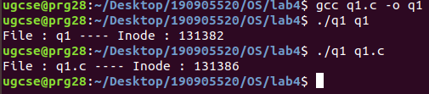
Question 2 : Write a program to print out the complete stat structure of a file.

Source Code :

#include <unistd.h>
#include <stdio.h>
#include <stdlib.h>
#include <sys/stat.h>
#include <sys/types.h>
#include <time.h>

char const *sperm(__mode_t mode) // to print modes
{
static char local_buff[16] = {0};
int i = 0;
// user permissions
if ((mode & S_IRUSR) == S_IRUSR)
local_buff[i] = 'r';
else
local_buff[i] = '-';
i++;
if ((mode & S_IWUSR) == S_IWUSR)
local_buff[i] = 'w';
else
local_buff[i] = '-';
i++;
if ((mode & S_IXUSR) == S_IXUSR)
local_buff[i] = 'x';
else
local_buff[i] = '-';
i++;
// group permissions
if ((mode & S_IRGRP) == S_IRGRP)
local_buff[i] = 'r';
else
local_buff[i] = '-';
i++;
if ((mode & S_IWGRP) == S_IWGRP)
local_buff[i] = 'w';
else
local_buff[i] = '-';
i++;
if ((mode & S_IXGRP) == S_IXGRP)
local_buff[i] = 'x';
else
local_buff[i] = '-';
i++;
// other permissions
if ((mode & S_IROTH) == S_IROTH)
local_buff[i] = 'r';
else
local_buff[i] = '-';
i++;
if ((mode & S_IWOTH) == S_IWOTH)
local_buff[i] = 'w';
else
local_buff[i] = '-';
i++;
if ((mode & S_IXOTH) == S_IXOTH)
local_buff[i] = 'x';
else
local_buff[i] = '-';
return local_buff;
}

int main(int argn, char* args[]){
if(argn < 2){
printf("Incorrect arguments, expected 1, got %d\n", argn-1);
return 0;
}
struct stat file_stat;
int return_value = stat(args[1], &file_stat);
if(return_value != 0){
perror("stat");
return 1;
}
printf("File : %s\nInode : %ld\nDevice Container ID : %ld\nMode : %10.10s\nHard Links : %ld\nUser ID : %d\nGroup ID : %d\nDevice ID : %ld\nTotal Size : %ld\nBlock Size : %ld\nNumber of blocks : %ld\nLast Access Time : %sLast Modified : %sLast Status Change : %s", args[1], file_stat.st_ino, file_stat.st_dev, sperm(file_stat.st_mode),file_stat.st_nlink, file_stat.st_uid, file_stat.st_gid, file_stat.st_rdev, file_stat.st_size, file_stat.st_blksize, file_stat.st_blocks, ctime(&file_stat.st_atime), ctime(&file_stat.st_mtime), ctime(&file_stat.st_ctime));
return 0;
}

Output :
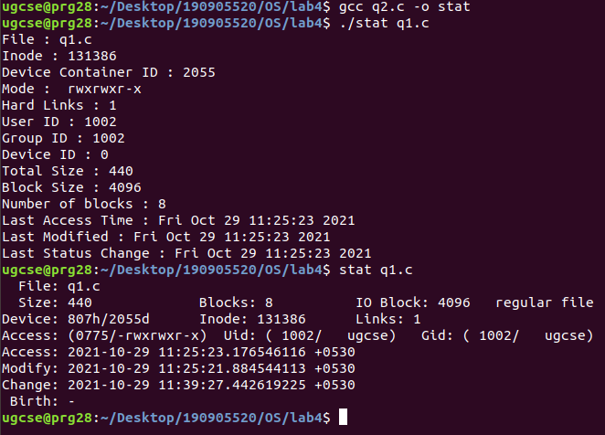

Question 3 : Write a program to create a new hard link to an existing file and unlink the same. Accept the old path as input and print the newpath.

Source Code :

#include <unistd.h>
#include <stdio.h>
#include <stdlib.h>
#include <sys/stat.h>
#include <sys/types.h>

int main(int argn, char* args[]){
if(argn < 2){
printf("Incorrect arguments, expected 1, got %d\n", argn-1);
return 0;
}
char *oldpath = args[1];
char *newpath = "newpath.txt";
struct stat file_stat;
printf("Before linking new link\n");
system("ls");
int return_value = stat(oldpath, &file_stat);
if(return_value != 0){
perror("stat");
return 1;
}
printf("Number of links before linking : %ld\n", file_stat.st_nlink);
link(oldpath, newpath);
printf("After linking new link\n");
system("ls");
int return_value_2 = stat(newpath, &file_stat);
if(return_value_2 != 0){
perror("stat");
return 1;
}
printf("Number of links after linking : %ld\nThe new path is : %s\n", file_stat.st_nlink, newpath);
unlink(oldpath);
printf("After unlinking old link\n");
system("ls");
int return_value_3 = stat(newpath, &file_stat);
if(return_value_3 != 0){
perror("stat");
return 1;
}
printf("Number of links after unlinking : %ld\n", file_stat.st_nlink);
return 0;
}

Output :

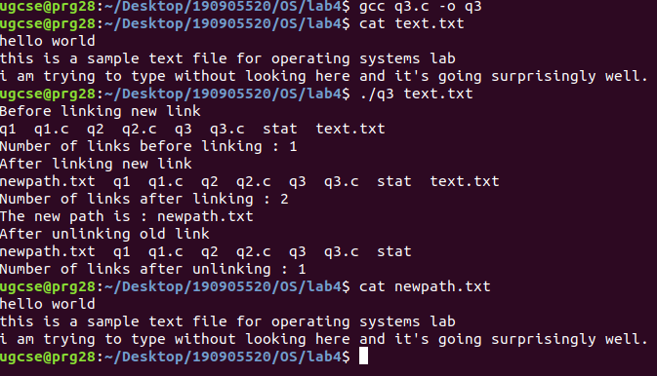
Question 4 : Write a program to create a new soft link to an existing file and unlink the same. Accept the old path as input and print the newpath.

Source Code :

#include <unistd.h>
#include <stdio.h>
#include <stdlib.h>
#include <sys/stat.h>
#include <sys/types.h>

int main(int argn, char* args[]){
if(argn < 2){
printf("Incorrect arguments, expected 1, got %d\n", argn-1);
return 0;
}
char *oldpath = args[1];
char *newpath = "newpath.txt";
struct stat file_stat;
printf("Before linking new link\n");
system("ls");
int return_value = stat(oldpath, &file_stat);
if(return_value != 0){
perror("stat");
return 1;
}
printf("Number of links before linking : %ld\n", file_stat.st_nlink);

symlink(oldpath, newpath);

printf("After linking new link\n");
system("ls");
int return_value_2 = stat(newpath, &file_stat);
if(return_value_2 != 0){
perror("stat");
return 1;
}
printf("Number of links after linking : %ld\nThe new path is : %s\n", file_stat.st_nlink, newpath);
unlink(newpath);
printf("After unlinking new soft link\n");
system("ls");
int return_value_3 = stat(oldpath, &file_stat);
if(return_value_3 != 0){
perror("stat");
return 1;
}
printf("Number of links after unlinking : %ld\n", file_stat.st_nlink);
return 0;
}

Output :
